PROGRAM NO:01
#include <iostream>
using namespace std;
int calculate2Low(int arr[], int size)
{
int lowest = arr[0];
for (int i = 1; i < size; i++)
{
if (arr[i] < lowest)
{
lowest = arr[i];
}
}

int secondLowest = 1000000;
for (int i = 0; i < size; i++)
{
if (arr[i] > lowest && arr[i] < secondLowest)
{
secondLowest = arr[i];
}
}

return secondLowest;
}
int calculate2High(int arr[], int size)
{
int highest = arr[0];
for (int i = 1; i < size; i++)
{
if (arr[i] > highest)
{
highest = arr[i];
}
}

int secondHighest = -1000000;
for (int i = 0; i < size; i++)
{
if (arr[i] < highest && arr[i] > secondHighest)
{
secondHighest = arr[i];
}
}

return secondHighest;
}

int main()
{
int N;

cin >> N;

int scores[N];

for (int i = 0; i < N; i++)
{
cin >> scores[i];
}

cout << "2nd Lowest Score: " << calculate2Low(scores, N) << endl;
cout << "2nd Highest Score: " << calculate2High(scores, N) << endl;

return 0;
}
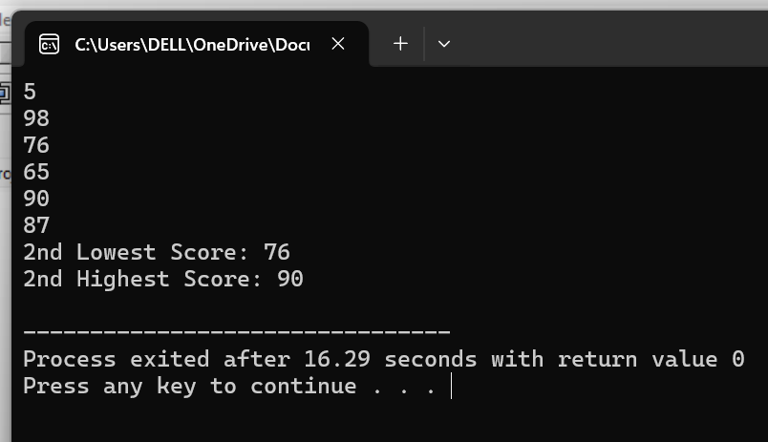

PROGRAM NO:02
#include <iostream>
#include <iomanip>
using namespace std;

double calculateSum(int arr[], int size)
{
int sum = 0;

for (int i = 0; i < size; i++)
{
sum += arr[i];
}

return sum;
}

int main()
{
int N;
cin >> N;

int scores[N];

for (int i = 0; i < N; i++)
{
cin >> scores[i];
}

double total = calculateSum(scores, N);

cout << fixed << setprecision(2) << total << endl;

return 0;
}
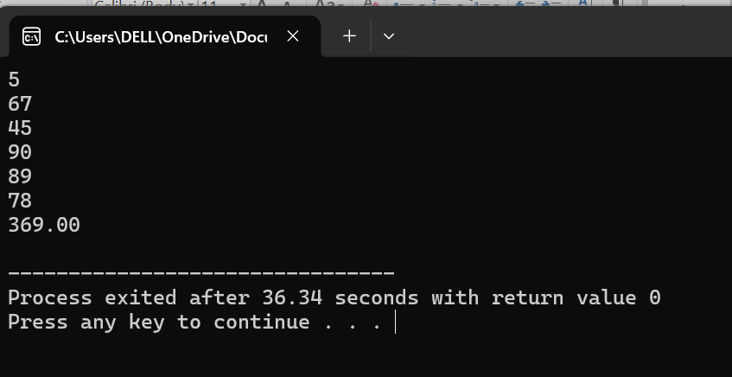

PROGRAM NO:03
#include <iostream>
#include <iomanip>
using namespace std;
double celsiusToFahrenheit(double celsius)
{
return (celsius * 9.0 / 5.0) + 32;
}

int main()
{
double celsius;

cin >> celsius;

double fahrenheit = celsiusToFahrenheit(celsius);

cout << fixed << setprecision(1) << fahrenheit << endl;

return 0;}
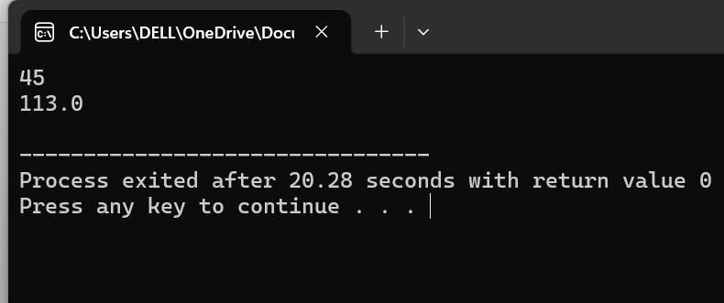
PROGRAM NO:04
#include <iostream>
using namespace std;

bool isLeapYear(int year) {
if ((year % 400 == 0) || (year % 4 == 0 && year % 100 != 0)) {
return true;
}
return false;
}

int main() {
cout << isLeapYear(2024);
return 0;
}
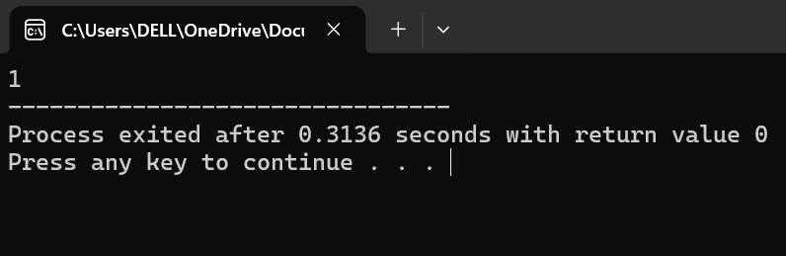

PROGRAM NO:05
#include <iostream>
using namespace std;

int countVowels(char word[])
{
int count = 0;

for (int i = 0; word[i] != '\0'; i++)
{
if (word[i] == 'a' || word[i] == 'e' || word[i] == 'i' ||
word[i] == 'o' || word[i] == 'u' ||
word[i] == 'A' || word[i] == 'E' || word[i] == 'I' ||
word[i] == 'O' || word[i] == 'U')
{
count++;
}
}

return count;
}

int main()
{
char name[100];

cin >> name;

cout << "Total Vowels: " << countVowels(name);

return 0;
}
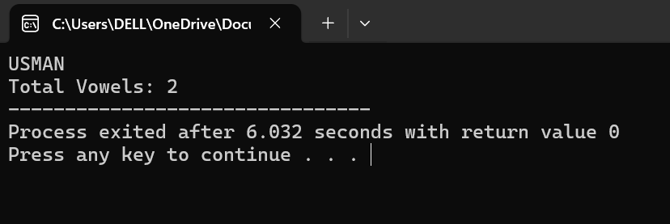

PROGRAM NO:06
#include <iostream>
using namespace std;

int main()
{
char arr[5];
char temp;

for (int i = 0; i < 5; i++)
{
cin >> arr[i];
}
for (int i = 0; i < 4; i++)
{
for (int j = 0; j < 4 - i; j++)
{
if (arr[j] > arr[j + 1])
{
temp = arr[j];
arr[j] = arr[j + 1];
arr[j + 1] = temp;
}
}
}

cout << "Sorted Letters: ";
for (int i = 0; i < 5; i++)
{
cout << arr[i] << " ";
}

return 0;
}
